19EEE 111- ELECTRICAL AND ELECTRONICS ENGINEERING

(Answer all questions)

1. A two-legged core is shown in the fig. 1. The winding on the left leg (*N*1) has 600 turns, and the winding on the right (*N*2) has 200 turns. The coils are wound in the directions shown in the figure. If the dimensions are as shown, then calculate the reluctance of the magnetic circuit. Currents. Assume *μr* =1500 and constant. [3M]

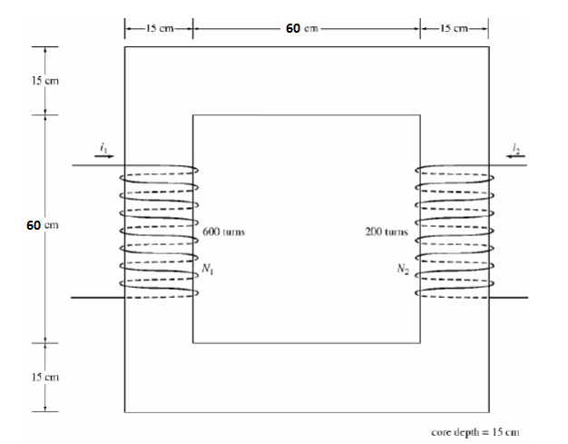

Fig. 1

1. What is depletion region in a PN junction diode? Why a diode does not conduct in reverse biased condition? [3M]
2. Analyze the signal shown in fig. 2 and calculate the time period and frequency. Assume X axis time in milliseconds.[3M]

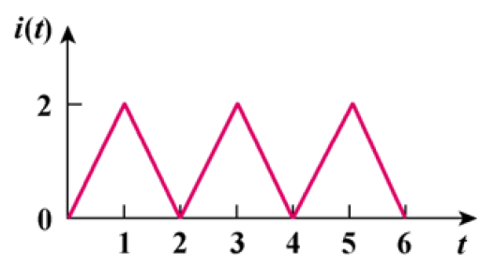

Fig. 2

1. Let **X** = 8∠40*°*. What is x(t) if frequency of the signal is 60 Hz. [3M]
2. State few applications of rectifier circuit. [3M]